**Approval process of ESC application in EWF**

If user wants to get access to particular application of ESC and he requested through ESC then his request will move to EWF:

Requester will able to find the status of his request by following below steps:

1. Login into respected environment of EWF with users credential.
2. Click on My Workflows Tab
3. If request is still pending from user’s manager then user will find the status of his request in Pending tab

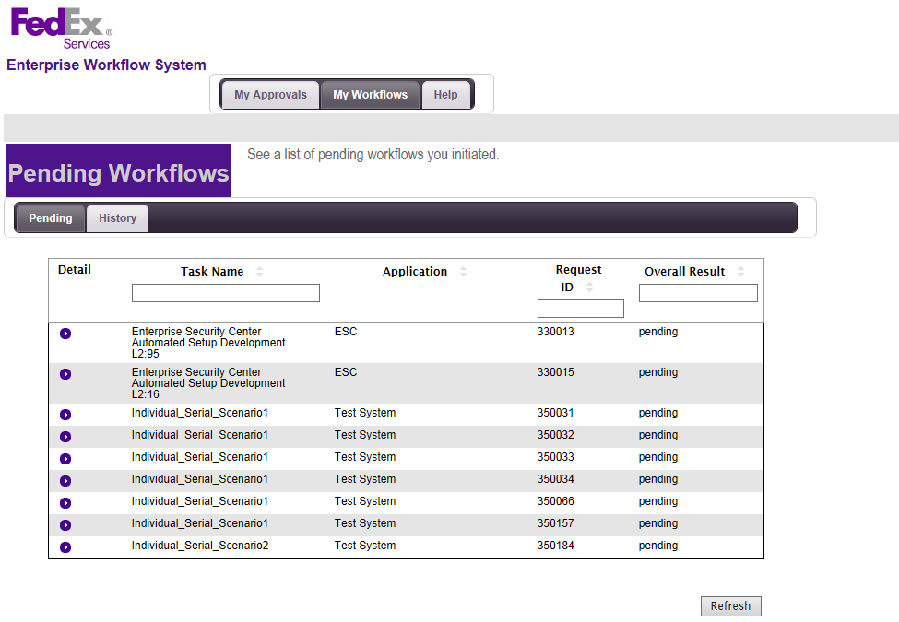

1. If request is still pending so he can click on Detail and will find with whom request is pending by clicking on Detail of particular task name

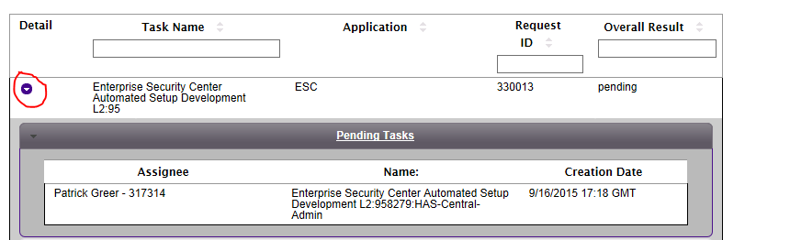

1. Then user can directly contact with that person in above example users request is pending with Patrick Greer.
2. If his request is approved then he can check it in History Tab.

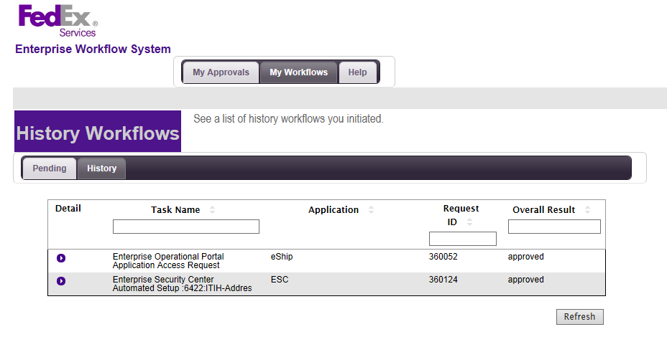 **How to provide access for particular application of ESC in EWF**

Once users request come under the Managers queue then he can approve or deny the request by following below steps:

1. Login into respected environment of EWF with his Managers credential.
2. In My Approvals tab he will able to see the request in his queue you can see this in below scree shot:

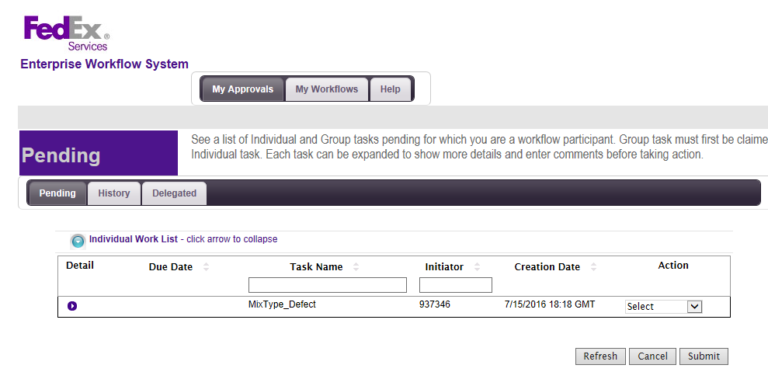

1. Click on Select button of select box
2. Here you can find the options like approved, denied, etc. After selecting required option click on Submit button.

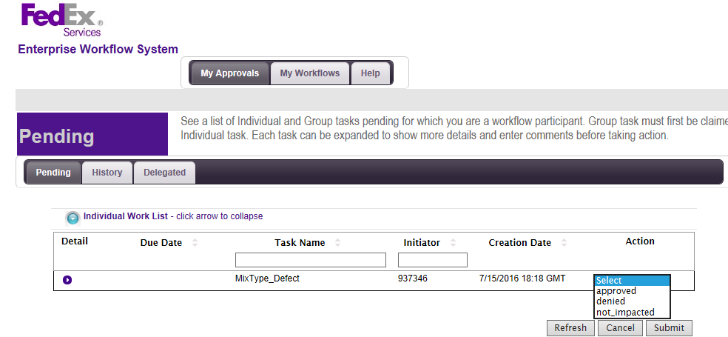

In this way the user will get access for initiated application.

**In Case of *wrong workflow generation* for eOps:**

In some cases, user generates some wrong workflows by mistake. So delete such kind of wrongly generated workflows we can raise a ticket with "eOPS-Support@fedex.com" with the complete details for the workflow and then they can able to delete all of the workflow in 1 shot.